EPC EXPRESS SURREY-“YOUR LOCAL LEGIONAIRES SAFETY TESTER”…
www.epcsurrey.co.uk

Legionnaires disease – High health and safety risk to tenants!
“Entering into spring and summer, typically a spike in Legionnaires disease cases occur.
Surprisingly, the increase in cases are attributed to the dangers that lie in people’s homes, rather than foreign holiday resorts”
The stagnant water in homes provides a perfect breathing ground for legionella bacteria growth. As a result, misplaced blame is often attributed to distant rather than domestic sources, when the spike in reported cases occur.
If you do get sick, it is important to recognise the symptoms and seek medical assistance as soon as possible, as Legionnaires disease can be fatal.
Legionnaires disease is a form of pneumonia caused by legionella bacteria, which breathes in water. It originates from legionellosis, which covers any illness caused by legionella bacteria.
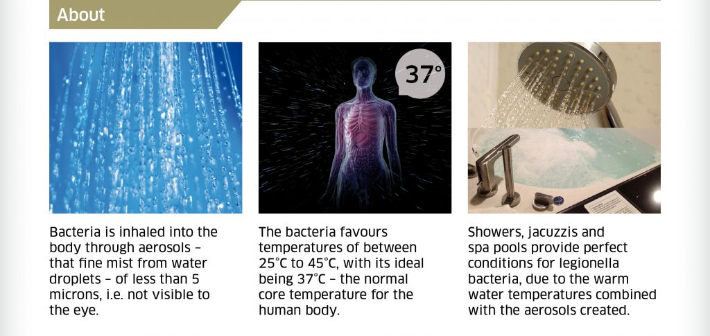
History
Legionnaires disease owes its name to the American Legion, whose annual conference was the subject of the first known outbreak of the illness in 1976.
The event took place at the Bellevue Hotel in Philadelphia. 34 people died and 221 people got sick. Amazingly, seven of the dead weren’t even in the hotel, including a nearby bus driver.
It took seven months to locate the cause of the outbreak. Initially it was thought the outbreak was caused by food contamination or a terrorist attack.
Causes
Legionnaires disease is caused by legionella bacteria.
The bacteria is inhaled into the body through aerosols – that fine mist from water droplets – of less than 5 microns, i.e. not visible to the eye.
Buildings are a perfect breathing ground for bacteria growth, owing to their heat, ideal temperatures and the presence of little used pipework.
The bacteria favours temperatures of between 25°C to 45°C, with 37°C an ideal temperature. Coincidentally, 37°C is the temperature we like our water at and is also the normal core temperature for the human body.
Stagnant water provides an ideal breathing ground, for the growth of legionella bacteria.
Showers, jacuzzis and spa pools also provide perfect conditions for legionella bacteria, due to the warm water temperatures combined with the aerosols created.
Signs and symptoms
Legionnaires disease is a severe disease and the symptoms are very common. The disease brings on a severe form of pneumonia, which makes it fatal. Its symptoms include:

  - High fever
  - Chills;
  - Headaches;
  - Muscle pains;
  - Breathlessness;
  - Dry cough;
  - Diarrhoea;
  - Vomiting;
  - Confusion.
Those at risk
- Men are most at risk, for no biological reason. This is probably because of the presence of process water systems and the volume of pipework in industrial environments, where the workforce is predominantly male.
- People over the age of 40, due to their weaker immune systems.
- Smokers, as Legionnaires is a pulmonary disease.
- Drinkers.
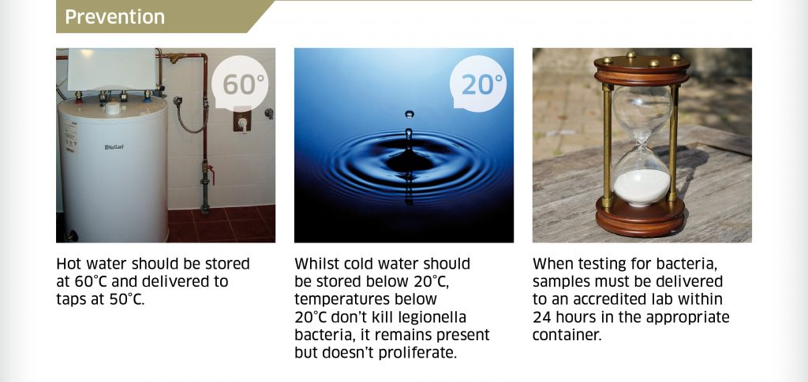
Prevention
Water systems maintained properly can control legionella bacteria through a cleaning regime and the prevention of stagnation.
Entirely enclosed water tanks can prevent animals such as: bats; pigeons; cats or even squirrels falling in, ensuring cleanliness.
Store hot water at 60°C and deliver to taps at 50°C.
Whilst cold water should be stored below 20°C, temperatures below 20°C don’t kill legionella bacteria, it remains present but doesn’t proliferate. Indeed, legionella bacteria has been found in ice, therefore cold doesn’t kill legionella bacteria.
Prevention is better than cure. Once bacteria colonises a system, it is almost impossible to get rid of it, especially if there are any dead legs (unused pipework) present in the system.
Treatment
Flushing of water outlets is one of the most menial tasks but one of the most important. Therefore, staff performing flushing need to be educated through training, to understand why this menial task is so important.
Little used outlets should be flushed on weekly basis. Both little used outlets and dead legs pose the greatest risks in a system.
Testing
- Test water samples need to be stored in an appropriate sterilised bottle and kept in a darkened area.
- Test samples must be delivered to a laboratory within 24 hours.
- Testing laboratories must operate in accordance with ISO 17025:2005 – general requirements for the competence of testing and calibration laboratories (including sampling).
Outbreaks and risks
In 2016 a G4S worker in England contracted Legionnaires disease. It could not be established whether or not he got sick at the company’s office or elsewhere, but the company were prosecuted.
G4S were still fined £1.8 million – even though the illness could not be traced back to their water system – as they had failed to properly address the risks, present in their water system. There was found to be:
- No water monitoring;
- No risk assessment;
- No sampling.
Law/guidelines
In Ireland, regulations are contained in the National Guidelines for the Control of legionellosis in Ireland 2009.
It is important to note in the Irish guidelines – in paragraph 4.2 on page 36 – who is clearly responsible for the control of legionella in the workplace:
“…there is a legal obligation on employers to carry out a risk assessment in relation to Legionella prevention and control in the workplace and where a risk is identified the appropriate control measures should be put in place and a risk management plan adopted”.

